Technology Stack (Architecture & Stack)

Date | 23 September 2026
Team ID | SWTID-2026-9722
Project Name | AI Weatherwise

Technical Architecture:
Overview: The system architecture follows a RESTful Client-Server model where the client interacts with an Express.js backend. The backend manages authentication via JWT, communicates with MongoDB via Mongoose for persistent data storage, fetches meteorological data from OpenWeather API, and processes clothing recommendations via the Google Gemini AI API.
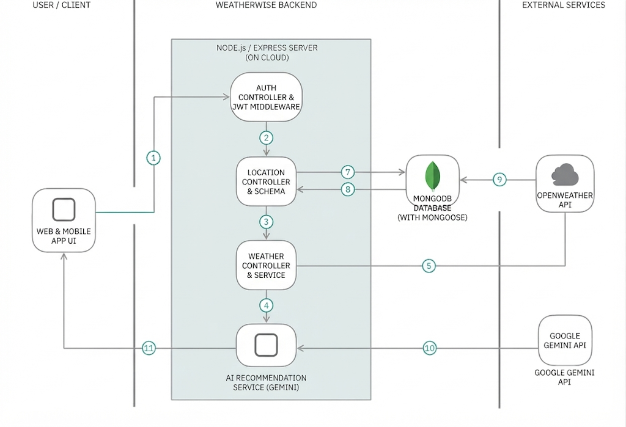

Guidelines:
- Include all the processes (As an application logic / Technology Block):
Express.js routing (authRoutes, locationRoutes, weatherRoutes, aiRoutes)
Controller logic (authController, locationController, weatherController, aiController)
Middleware authentication (authMiddleware.js)
- Provide infrastructural demarcation (Local / Cloud):
Local Server Infrastructure: Node.js runtime environment running Express.js on Port 5001 (server.js, app.js).
Cloud / External Infrastructure: OpenWeather REST API service and Google Gemini Generative AI cloud endpoints.
- Indicate external interfaces (Third-party APIs etc.):
OpenWeather API ([https://api.openweathermap.org](https://api.openweathermap.org)) for real-time weather data.
Google Generative AI SDK (@google/generative-ai) utilizing the gemini-1.5-flash model.
- Indicate Data Storage components / services:
MongoDB NoSQL database connected via Mongoose ODM (config/db.js), utilizing compound unique indexing for saved user locations (locationSchema.index).
- Indicate interface to machine learning models (if applicable):
Direct API integration with Google's Gemini 1.5 Flash large language model for automated, context-aware meteorological clothing recommendations and rule-based fallback handlers.
Table-1 : Components & Technologies:
S.No | Component | Description | Technology
1. | User Interface | How user interacts with application (Client Layer) | HTML, CSS, JavaScript / React (REST API Consumer)
2. | Application Logic-1 | Core Backend API Logic & Routing. | Node.js, Express.js
3. | Application Logic-2 | Authentication & Authorization middleware . | JSON Web Tokens (jsonwebtoken), bcryptjs
4. | Application Logic-3 | Weather Service Integration & AI Processing logic | Axios, Google Generative AI SDK (@google/generative-ai)
5. | Database | NoSQL Document Data Storage & Configurations | MongoDDatabase B, Mongoose ODM
6. | Cloud Database | Hosted Database Service (Optional / Production) | MongoDB Atlas
7. | File Storage | Environment & configuration file management | Local Filesystem (dotenv)
8. | External API-1 | Real-time weather data fetching | OpenWeather API
9. | External API-2 | Generative text/recommendation processing | Google Gemini API (gemini-1.5-flash)
10. | Machine Learning Model | Natural Language Generative Model | Google Gemini Flash LLM
11. | Infrastructure (Server / Cloud) | Application Deployment on Local System / Cloud. | Local Node.js Runtime Server (Port 5001) / Cloud PaaS

Table-2: Application Characteristics:
S.No | Characteristics | Description | Technology
1. | Open-Source Frameworks | List the open-source frameworks used | Express.js, Mongoose, Axios, Cors
2. | Security Implementations | List all the security / access controls implemented, | JWT Bearer Token Authentication, bcryptjs password hashing, CORS middleware
3. | Scalable Architecture | Justify the scalability of architecture (3 – tier, Micro-services) | Modular MVC-style backend separation (Routers, Controllers, Services, Models)
4. | Availability | Justify the availability of application. | Robust try-catch exception handling and fallback engines for external third-party services
5. | Performance | Design consideration for the performance of the application . | MongoDB indexing on user-location fields to optimize search lookup speeds

References:
- API & System Architecture Design:
https://c4model.com/[cite: 3]
- Cloud Backend System Patterns & Microservices Integration:
https://developer.ibm.com/patterns/online-order-processing-system-during-pandemic/[cite: 3]
- Cloud Architecture & Scalability Considerations:
https://www.ibm.com/cloud/architecture[cite: 3]
- Cloud Security & Infrastructure Reliability (AWS/Cloud standards):
https://aws.amazon.com/architecture[cite: 3]
- Technical Architecture Diagram Best Practices:
https://medium.com/the-internal-startup/how-to-draw-useful-technical-architecture-diagrams-2d20c9fda90d[cite: 3]
- Express.js Application Framework Documentation:
https://expressjs.com/
- Mongoose ODM & MongoDB NoSQL Modeling:
https://mongoosejs.com/docs/guide.html
- Google Generative AI SDK (@google/generative-ai):
https://ai.google.dev/docs
- OpenWeather REST API Documentation:
https://openweathermap.org/api

